Course: CSN 405 – Network Programming
LAB 5 – Asynchronous Socket Programming

Student name | Phan Ngọc Hạnh Nhi
Student ID | 2131209002

Question 1
Write a Python program using asyncio that acts as a prime-check server.
Requirements:
- Client sends an integer n, server replies TRUE if prime else FALSE
- Log each request to server.log as:
[TIME] PORT NUMBER RESULT
Example Communication:
- [CLIENT] Enter number: 17
Server reply: [SERVER] TRUE

server.log:
[2026-03-04 15:10:02] 54231 17 TRUE
[2026-03-04 15:10:07] 54235 20 FALSE
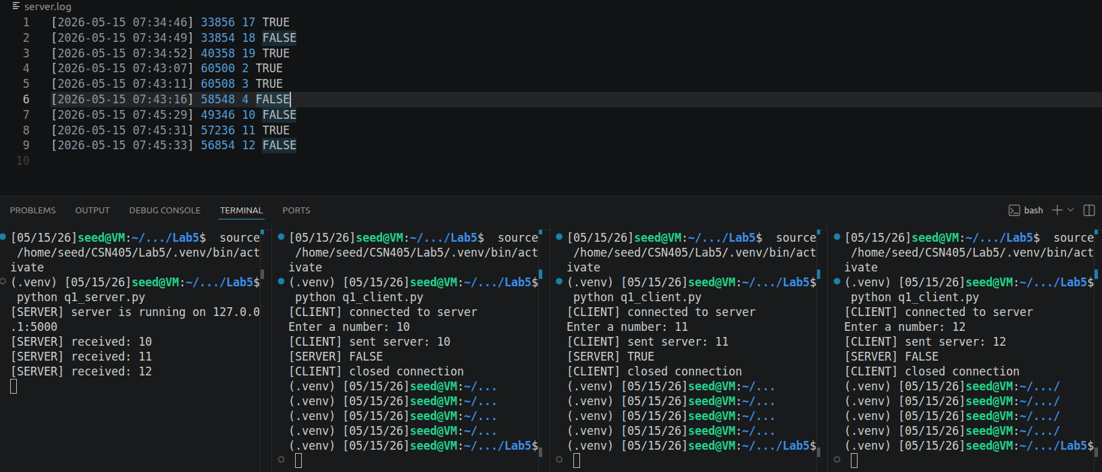
Question 2:
Modify Question 1 code (server and client) and write a Python program that acts as below:
Requirements
- Client can send commands (one per line):
  - PRIME n → reply YES if n is prime else NO
  - NEXT_PRIME n → reply the smallest prime >= n
  - FACT n → reply n! (limit: n <= 100, else ERROR)
- Server supports many requests in the same connection until client sends QUIT
- Each request is logged to server.log as:
[TIME] PORT REQUEST RESULT

Example communication
- Client: PRIME 17 → Server: [SERVER] YES
- Client: NEXT_PRIME 20 → Server: [SERVER] 23
- Client: FACT 10 → Server: [SERVER] 3628800

server.log:
[2026-03-04 16:01:10] 53122 PRIME 17 YES
[2026-03-04 16:01:15] 53122 NEXT_PRIME 20 23
[2026-03-04 16:01:18] 53122 FACT 10 3628800
[2026-03-04 16:01:22] 53122 QUIT BYE
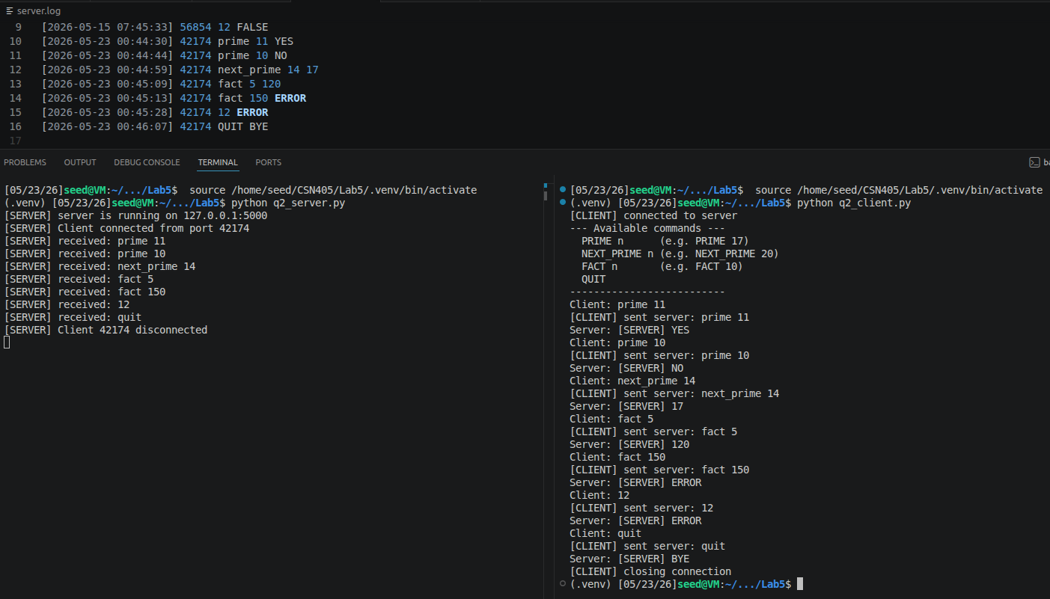
Question 3:
Write a Python program using asyncio that acts as a number statistics server.
Requirements
- A client sends a list of integers separated by spaces (for example: 3 7 10 5).
- The server calculates:
  - SUM of the numbers
  - MIN number
- The server replies in this format:
[SERVER] SUM=<sum> MIN=<min>

Example communication
[CLIENT] Enter numbers: 3 7 10 5
Server reply: [SERVER] SUM=25 MIN=3

Server.log:
[2026-03-04 17:10:02] 53214 3 7 10 5 SUM=25 MIN=3
[2026-03-04 17:10:08] 53214 4 9 2 SUM=15 MIN=2

